**Lake Bumbunga - Lochiel's Pink Lake**

**Visit Lake Bumbunga - South Australia's famous pink lake**

[Lake Bumbunga(408 kb)](https://www.wrc.sa.gov.au/webdata/resources/files/Lake%20Bumbunga%20brochure.pdf) sits alongside the quaint township of Lochiel, 130kms north of Adelaide, straddling the Clare Valley and Yorke Peninsula tourist regions.

Feast your eyes on bubble gum shores, then sip your way through the heart of Australian riesling country on a [**three-day road trip**](https://southaustralia.com/travel-blog/rewards-wonder-clare-valley) through the [Clare Valley](https://southaustralia.com/places-to-go/clare-valley).

#### How to get there

From Adelaide Hire a car and hit the road to enjoy Australia’s real ‘land of sweeping plains’ as you head north from the CBD via Main North Road. At Gepps Cross, continue straight as you cross onto Port Wakefield Road (leaving Main North Road), continue straight for about 30 minutes until you see the turnoff to Balaklava to your right. Enjoy a pitstop in Balaklava before continuing the same direction, following the signs to Lochiel. Please do not drive on the lake.

**To earn extra cashback 5%:**

**1. Submit your answer (no worries correct answer will be available later)**

**2. Scan the QR code when you arrive the location** Flamingo Flamingo **of the quiz**

Quiz: Flamingo dye their color when they bath in lake.

## To access the bonus cashback 5% complete a treasure hunt puzzle and upload a photo with the treasure (scan the QR code to gain the puzzle piece).

1. Compete a hiking (below) in Balaklava.

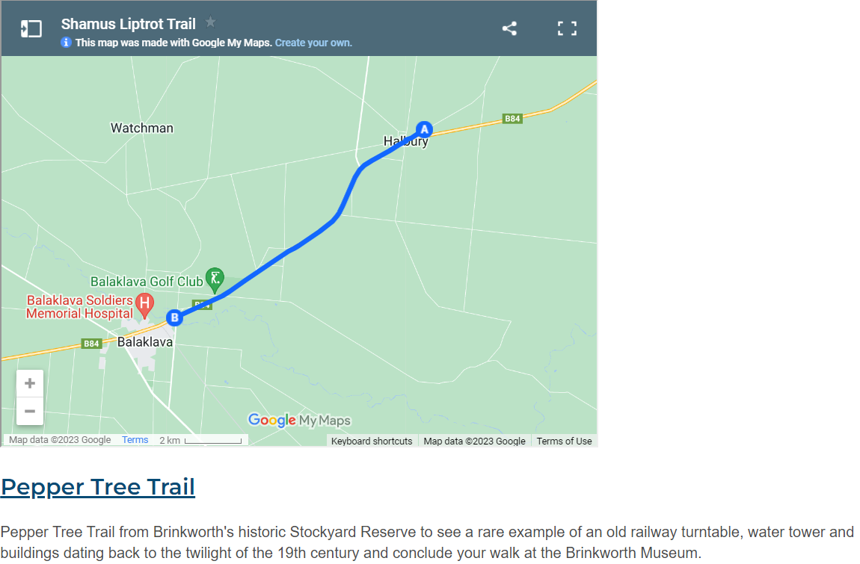

1. Upload your trip photo and complete the puzzle of the treasure hunt.

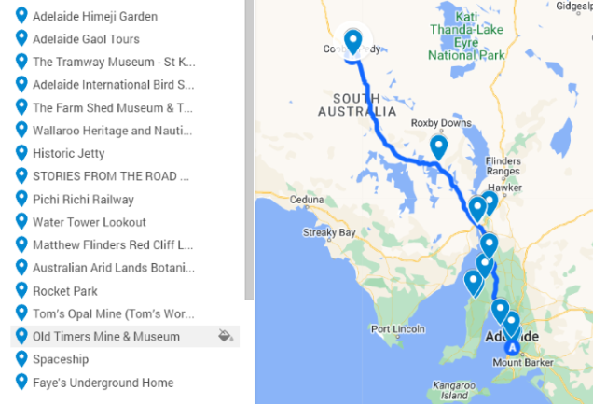

Playground

Local history

Museum

Playground

hiking

Filter